**DAILY ONLINE ACTIVITIES SUMMARY**

|  |  |  |  |  |  |  |  |
| --- | --- | --- | --- | --- | --- | --- | --- |
| **Date:** | **27/05/2020** | | | | **Name:** | **Churashma** | |
| **Sem & Sec** | **4th SEM 'A' Section** | | | | **USN:** | **4AL18CS019** | |
| **Online Test Summary** | | | | | | | |
| **Subject** | | **Object oriented concepts** | | | | | |
| **Max. Marks** | | **30** | | **Score** | | **24** | |
| **Certification Course Summary** | | | | | | | |
| **Course** | **Java programming** | | | | | | |
| **Certificate Provider** | | | **greatlearning academy** | **Duration** | | | **3.5 hours** |
| **Coding Challenges** | | | | | | | |
| **Problem statement 1:** Write a C Program to sort an array of integers in ascending order and display the sorted array and Number of passes performed for sorting. | | | | | | | |
| **Status: completed** | | | | | | | |
| **Uploaded the report in Github** | | | | **yes** | | | |
| **If yes Repository name** | | | | **https://github.com/Churashma/Lockdown-coding** | | | |
| **Uploaded the report in slack** | | | | **yes** | | | |

**ONLINE TEST DETAILS**: OOC test was scheduled from 09:15 am to 09:45am .The portion for the IA was 5th module there were 30 questions and the time assigned was 30 minutes the questions were mcq type.

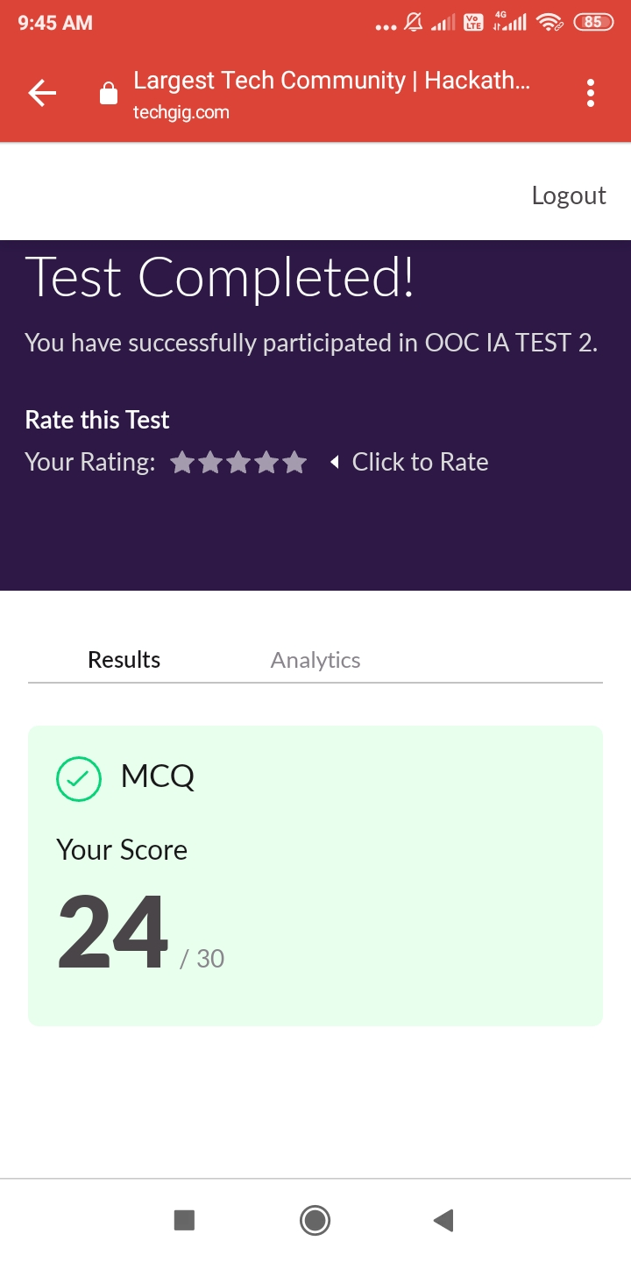

**CERTIFICATION COURSE DETAILS**: Today I studied about install Java and java IDE. You should create a NEW Java project for each of your Java application.Eclipse allows you to keep more than one programs in a project, which is handy for writing toy programs. To run a particular program, open and right-click on the source file ⇒ Run As ⇒ Java Application.Clicking the "Run" button (with a "Play" icon) runs the recently-run program . Try clicking on the "down-arrow" besides the "Run" button.

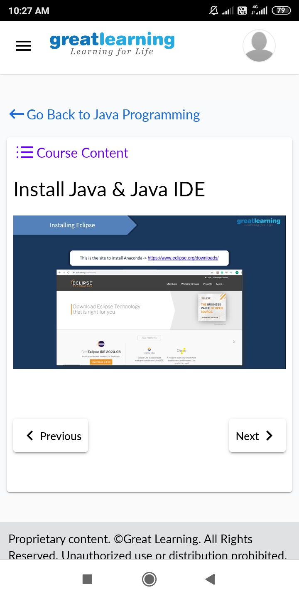

**CODING CHALLENGES DETAILS**:

**Problem statement 1:** In Bubble sort, each pass consists of comparison each element in the file with its successor (i.e. x[i] with x[i+1]) and interchanging two elements if they are not in the proper order. The array may be sorted in any pass. If the array is sorted, then remaining passes should be skipped off.Write a C Program to sort an array of integers in ascending order and display the sorted array and Number of passes performed for sorting.

